Домашнее задание №7
по дисциплине:
«Дискретная математика»

Вариант 28
A = 9,7; B = 0,073

Формат Ф1 (число разрядов мантиссы m = 12, ускоренное умножение по 2 разряда):

A = (9,7)₁₀ = (9,B333...)₁₆ ≈ (0,9B3)₁₆ * 16¹
X_{A} = (1 + 64)₁₀ = (65)₁₀ = (1000001)₂

0 | 1000001 | 100110110011
0 | 1 7 |  | 8 19

B = (0,073)₁₀ = (0,12B02...)₁₆ ≈ (0,12B)₁₆ * 16⁰
X_{B} = (0 + 64)₁₀ = (64)₁₀ = (1000000)₂

0 | 1000000 | 000100101011
0 | 1 7 |  | 8 19

SignC = SingA ⊕ SingB = 0 ⊕ 0 = 0

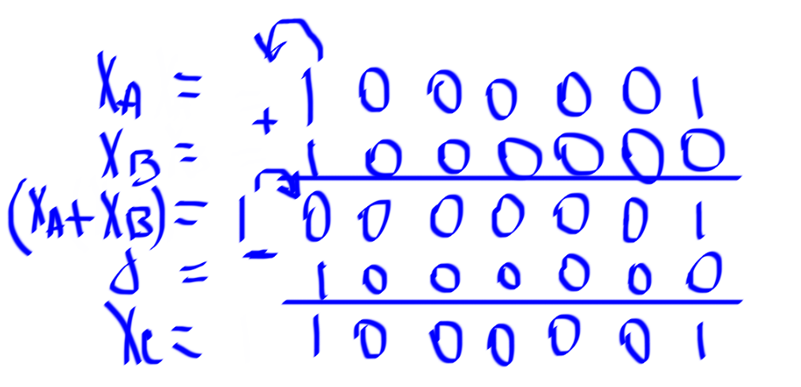

№ | Операнды | СЧП (старшие разряды) |  |  |  |  |  |  |  |  |  |  |  |  |  |  | В/СЧП (младшие  разряды) |  |  |  |  |  |  |  |  |  |  |  | Признак коррекции
0 | СЧП | 0 | 0 | 0 | 0 | 0 | 0 | 0 | 0 | 0 | 0 | 0 | 0 | 0 | 0 | 0 | 0 | 0 | 0 | 1 | 0 | 0 | 1 | 0 | 1 | 0 | 1 | 1 | 0
1 | –M_{A} | 1 | 1 | 1 | 0 | 1 | 1 | 0 | 0 | 1 | 0 | 0 | 1 | 1 | 0 | 1 | –M_{A} |  |  |  |  |  |  |  |  |  |  |  | 1
 | СЧП - M_{A} | 1 | 1 | 1 | 0 | 1 | 1 | 0 | 0 | 1 | 0 | 0 | 1 | 1 | 0 | 1 | 0 | 0 | 0 | 1 | 0 | 0 | 1 | 0 | 1 | 0 | 1 | 1
 | СЧП –> 2 | 1 | 1 | 1 | 1 | 1 | 0 | 1 | 1 | 0 | 0 | 1 | 0 | 0 | 1 | 1 | 0 | 1 | 0 | 0 | 0 | 1 | 0 | 0 | 1 | 0 | 1 | 0
2 | –M_{A} | 1 | 1 | 1 | 0 | 1 | 1 | 0 | 0 | 1 | 0 | 0 | 1 | 1 | 0 | 1 | –M_{A} |  |  |  |  |  |  |  |  |  |  |  | 1
 | СЧП - M_{A} | 1 | 1 | 1 | 0 | 0 | 1 | 1 | 1 | 1 | 1 | 0 | 0 | 0 | 0 | 0 | 0 | 1 | 0 | 0 | 0 | 1 | 0 | 0 | 1 | 0 | 1 | 0
 | СЧП –> 2 | 1 | 1 | 1 | 1 | 1 | 0 | 0 | 1 | 1 | 1 | 1 | 1 | 0 | 0 | 0 | 0 | 0 | 0 | 1 | 0 | 0 | 0 | 1 | 0 | 0 | 1 | 0
3 | –M_{A} | 1 | 1 | 1 | 0 | 1 | 1 | 0 | 0 | 1 | 0 | 0 | 1 | 1 | 0 | 1 | –M_{A} |  |  |  |  |  |  |  |  |  |  |  | 1
 | СЧП - M_{A} | 1 | 1 | 1 | 0 | 0 | 1 | 1 | 0 | 1 | 0 | 0 | 0 | 1 | 0 | 1 | 0 | 0 | 0 | 1 | 0 | 0 | 0 | 1 | 0 | 0 | 1 | 0
 | СЧП –> 2 | 1 | 1 | 1 | 1 | 1 | 0 | 0 | 1 | 1 | 0 | 1 | 0 | 0 | 0 | 1 | 0 | 1 | 0 | 0 | 0 | 1 | 0 | 0 | 0 | 1 | 0 | 0
4 | +M_{A} | 0 | 0 | 0 | 1 | 0 | 0 | 1 | 1 | 0 | 1 | 1 | 0 | 0 | 1 | 1 | +M_{A} |  |  |  |  |  |  |  |  |  |  |  | 0
 | СЧП + M_{A} | 0 | 0 | 0 | 0 | 1 | 1 | 0 | 1 | 0 | 0 | 0 | 0 | 1 | 0 | 0 | 0 | 1 | 0 | 0 | 0 | 1 | 0 | 0 | 0 | 1 | 0 | 0
 | СЧП –> 2 | 0 | 0 | 0 | 0 | 0 | 0 | 1 | 1 | 0 | 1 | 0 | 0 | 0 | 0 | 1 | 0 | 0 | 0 | 1 | 0 | 0 | 0 | 1 | 0 | 0 | 0 | 1
5 | +M_{A} | 0 | 0 | 0 | 1 | 0 | 0 | 1 | 1 | 0 | 1 | 1 | 0 | 0 | 1 | 1 | +M_{A} |  |  |  |  |  |  |  |  |  |  |  | 0
 | СЧП + M_{A} | 0 | 0 | 0 | 1 | 0 | 1 | 1 | 0 | 1 | 0 | 1 | 0 | 1 | 0 | 0 | 0 | 0 | 0 | 1 | 0 | 0 | 0 | 1 | 0 | 0 | 0 | 1
 | СЧП –> 2 | 0 | 0 | 0 | 0 | 0 | 1 | 0 | 1 | 1 | 0 | 1 | 0 | 1 | 0 | 1 | 0 | 0 | 0 | 0 | 0 | 1 | 0 | 0 | 0 | 1 | 0 | 0
6 | 0 | 0 | 0 | 0 | 0 | 0 | 0 | 0 | 0 | 0 | 0 | 0 | 0 | 0 | 0 | 0 | СЧП –> 2 |  |  |  |  |  |  |  |  |  |  |  | 0
 | СЧП | 0 | 0 | 0 | 0 | 0 | 1 | 0 | 1 | 1 | 0 | 1 | 0 | 1 | 0 | 1 | 0 | 0 | 0 | 0 | 0 | 1 | 0 | 0 | 0 | 1 | 0 | 0
 | СЧП –> 2 | 0 | 0 | 0 | 0 | 0 | 0 | 0 | 1 | 0 | 1 | 1 | 0 | 1 | 0 | 1 | 0 | 1 | 0 | 0 | 0 | 0 | 0 | 1 | 0 | 0 | 0 | 1
7 | 0 | 0 | 0 | 0 | 0 | 0 | 0 | 0 | 0 | 0 | 0 | 0 | 0 | 0 | 0 | 0 | СЧП <– 4
 | СЧП | 0 | 0 | 0 | 0 | 0 | 0 | 0 | 1 | 0 | 1 | 1 | 0 | 1 | 0 | 1 | 0 | 1 | 0 | 0 | 0 | 0 | 0 | 1 | 0 | 0 | 0 | 1
 | M_{C} | 0 | 0 | 0 | 1 | 0 | 1 | 1 | 0 | 1 | 0 | 1 | 0 | 1 | 0 | 0 | 0 | 0 | 0 | 1 | 0 | 0 | 0 | 1 | 0 | 0 | 0 | 0

X_{C} = X_{C} – 1

Результат умножения:

0 | 100000 | 101101010100
0 | 1 7 |  | 8 19

С* = (0,B54)₁₆ * 16⁰ = (0,B54)₁₆ = (0,7080078125)₁₀
С^{Т} = (9,7 * 0,073)₁₀ = (0,7081)₁₀
ΔС = (0,7080078125 – 0,7081)₁₀ = (0,0000921875)₁₀
δС = $\left|\frac{0,0000921875}{0,7081}\right|$ · 100% ≈ 0,013%

Погрешности результатов вызваны неточным представлением операндов и потерей младших бит СЧП.

Формат Ф2 (число разрядов мантиссы m = 11, ускоренное умножение по 4 разряда):

A = (9,7)₁₀ = (1001,10110011001)₂ ≈ (0,100110110011)₂ * 2⁴
X_{A} = (4 + 128)₁₀ = (132)₁₀ = (10000100)₂

0 | 10000100 | 00110110011
0 | 1 8 |  | 9 19

B = (0,073)₁₀ = (0,000100101011)₂ ≈ (0,100101011)₂ * 2⁻³
X_{B} = (–3 + 128)₁₀ = (125)₁₀ = (10000001)₂

0 | 01111101 | 00101011000
0 | 1 8 |  | 9 19

SignC = SingA ⊕ SingB = 0 ⊕ 0 = 0

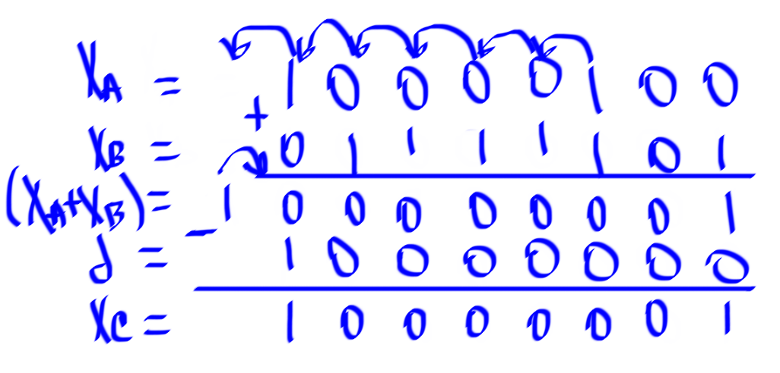

№ | Операнды | СЧП (старшие разряды) |  |  |  |  |  |  |  |  |  |  |  |  |  |  |  |  |  |  |  |  |  |  |  |  |  |  |  |  |  |  |  | В/СЧП (младшие  разряды) |  |  |  |  |  |  |  |  |  |  |  |  |  |  |  |  |  |  |  |  |  |  |  |  | Признак коррекции
0 | СЧП | 0 0 0 0 0 0 0 0 0 0 0 0 0 0 0 0 0 |  |  |  |  |  |  |  |  |  |  |  |  |  |  |  |  |  |  |  |  |  |  |  |  |  |  |  |  |  |  |  | 1 0 0 1 0 1 0 1 1 0 0 0 |  |  |  |  |  |  |  |  |  |  |  |  |  |  |  |  |  |  |  |  |  |  |  |  | 0
1 | +8M_{A} | 0 | 0 | 1 |  | 0 |  | 0 |  | 1 |  | 1 |  | 0 |  | 1 |  | 1 |  | 0 |  | 0 |  | 1 |  | 1 |  | 0 |  | 0 |  | 0 |  |  |  |  |  |  |  |  |  |  |  |  |  |  |  |  |  |  |  |  |  |  |  |  |  |  |  | 0
 | СЧП + 8M_{A} | 0 | 0 | 1 |  | 0 |  | 0 |  | 1 |  | 1 |  | 0 |  | 1 |  | 1 |  | 0 |  | 0 |  | 1 |  | 1 |  | 0 |  | 0 |  | 0 |  |  | 1 |  | 0 |  | 0 |  | 1 |  | 0 |  | 1 |  | 0 |  | 1 |  | 1 0 |  |  |  | 0 0
 | СЧП –> 4 | 0 | 0 | 0 |  | 0 |  | 0 |  | 0 |  | 1 |  | 0 |  | 0 |  | 1 |  | 1 |  | 0 |  | 1 |  | 1 |  | 0 |  | 0 |  | 1 |  |  | 1 |  | 0 |  | 0 |  | 0 |  | 1 |  | 0 |  | 0 |  | 1 |  | 0 |  | 1 |  | 0 |  | 1
2 | +4M_{A} | 0 | 0 | 0 |  | 1 |  | 0 |  | 0 |  | 1 |  | 1 |  | 0 |  | 1 |  | 1 |  | 0 |  | 0 |  | 1 |  | 1 |  | 0 |  | 0 |  |  |  |  |  |  |  |  |  |  |  |  |  |  |  |  |  |  |  |  |  |  |  |  |  |  |  | 0
 | +M_{A} | 0 | 0 | 0 |  | 0 |  | 0 |  | 1 |  | 0 |  | 0 |  | 1 |  | 1 |  | 0 |  | 1 |  | 1 |  | 0 |  | 0 |  | 1 |  | 1
 | СЧП + 4M_{A} + M_{A} | 0 | 0 | 0 |  | 1 |  | 1 |  | 0 |  | 1 |  | 0 |  | 1 |  | 0 |  | 1 |  | 0 |  | 1 |  | 1 |  | 0 |  | 0 |  | 0 |  |  | 1 |  | 0 |  | 0 |  | 0 |  | 1 |  | 0 |  | 0 |  | 1 |  | 0 1 |  |  |  | 0 1
 | СЧП –> 4 | 0 | 0 | 0 |  | 0 |  | 0 |  | 0 |  | 0 |  | 1 |  | 1 |  | 0 |  | 1 |  | 0 |  | 1 |  | 0 |  | 1 |  | 0 |  | 1 |  |  | 1 |  | 0 |  | 0 |  | 0 |  | 1 |  | 0 |  | 0 |  | 0 |  | 1 |  | 0 |  | 0 |  | 1
3 | +8M_{A} | 0 | 0 | 1 |  | 0 |  | 0 |  | 1 |  | 1 |  | 0 |  | 1 |  | 1 |  | 0 |  | 0 |  | 1 |  | 1 |  | 0 |  | 0 |  | 0 |  |  |  |  |  |  |  |  |  |  |  |  |  |  |  |  |  |  |  |  |  |  |  |  |  |  |  | 0
 | +M_{A} | 0 | 0 | 0 |  | 0 |  | 0 |  | 1 |  | 0 |  | 0 |  | 1 |  | 1 |  | 0 |  | 1 |  | 1 |  | 0 |  | 0 |  | 1 |  | 1
 | СЧП + 8M_{A} + M_{A} | 0 | 0 | 1 |  | 0 |  | 1 |  | 1 |  | 0 |  | 1 |  | 0 |  | 1 |  | 0 |  | 1 |  | 0 |  | 0 |  | 0 |  | 0 |  | 0 |  |  | 1 |  | 0 |  | 0 |  | 0 |  | 1 |  | 0 |  | 0 |  | 0 |  | 1 0 |  |  |  | 0 1
 | СЧП –> 4 | 0 | 0 | 0 |  | 0 |  | 0 |  | 0 |  | 1 |  | 0 |  | 1 |  | 1 |  | 0 |  | 1 |  | 0 |  | 1 |  | 0 |  | 1 |  | 0 |  |  | 0 |  | 0 |  | 0 |  | 0 |  | 1 |  | 0 |  | 0 |  | 0 |  | 1 |  | 0 |  | 0 |  | 0
4
 | СЧП <– 1 | 0 | 0 |  | 0 |  | 0 |  | 0 |  | 1 |  | 0 |  | 1 |  | 1 |  | 0 |  | 1 |  | 0 |  | 1 |  | 0 |  | 1 |  | 0 |  | 0 |  |  | 0 |  | 0 |  | 0 |  | 1 |  | 0 |  | 0 |  | 0 |  | 1 |  | 0 |  | 0 |  | 0 |  | 0

Результат умножения:

0 | 10000001 | 01101010100
0 | 1 8 |  | 9 19

С* = (3)₂ * 2¹ = (0,1101010100)₂ = (0,83203125)₁₀
С^{Т} = (9,7 * 0,073)₁₀ = (0,7081)₁₀
ΔС = (0.83203125 – 0,7081)₁₀ = (0,12393125)₁₀
δС = $\left|\frac{0,12393125}{0,7081}\right|$ · 100% ≈ 0,76%

Погрешности результатов вызваны неточным представлением операндов и потерей младших бит СЧП.

